# **Check Tomcat Version**

**Steps To Check Tomcat Version On Windows:**

1. Open CMD or Command Prompt as Administrator.

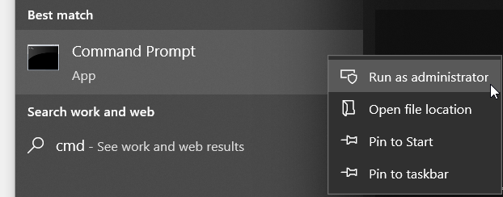

1. Go to Tomcat bin folder.

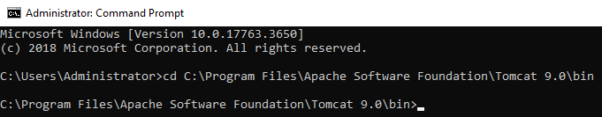

1. Run command "version.bat". After that, details about Tomcat version will be appeared.

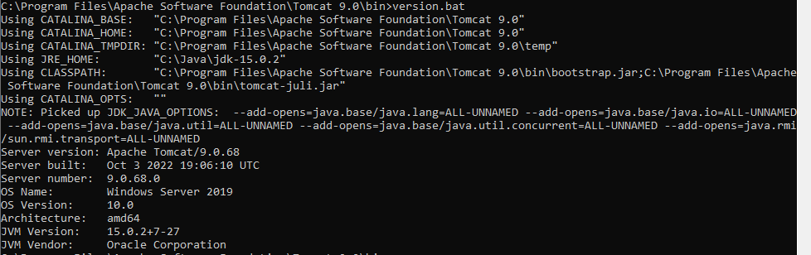

|  |
| --- |
| version.bat |

**Steps To Check Tomcat Version On Linux:**

1. Go to Tomcat bin folder.

|  |
| --- |
| cd /opt/tomcat9/bin/ |

1. Run command "sh version.sh". After that, details about Tomcat version will be appeared.

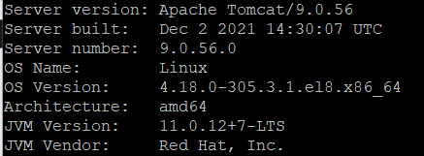

|  |
| --- |
| sh version.sh |